SOFTWARE DETAIL DESIGN DOCUMENT

HUMAN RESOURCE MANAGEMENT
Software Detail Design (SDD)

Version 1.0, issued date …..
ABSTRACT
This document is intended to be the SRS and ADD for developing
PERSONAL INFORMATION MANAGEMENT (HRM_PIM)

PROPRIETARY INFORMATION: The information contained in this document is the property of HRM_PIM . Except as specifically authorized in writing by HRM_PIM, the holder of this document shall keep all information contained herein confidential and shall protect same in whole or in part from disclosure and dissemination to all third parties.
History revision
Name | Date | Version | Description

Contents
1. Introduction 4
1.1. Purpose 4
1.2. Goals and Objectives 4
1.3. Constraints 4
1.4. Intended Audience and Reading Suggestions 4
2. Architectural and Component-Level Design 5
2.1. Architecture diagram 5
2.2. Description of Components 6
2.3. Requirements Traceability Matrix 6
3. Data Architecture 6
3.1. Entity-Relation Diagram 6
3.2. Temporary data structure(s) 6
4. File List Description 6
5. Detail Design 6

Introduction

Purpose
This document presents the detailed design for the HRM system. The purposes of this document are as below:
- To supports the Developer having the overall software design. Based on this document, Developer will be able to implement the system easily.
- To supports Developer writing Unit test.
- To supports tester (QC) writing Integration test.

Goals and Objectives

All components to be developed will be enumerated and described within this document to the level of detail necessary to begin implementation.

Constraints

This document will address functional requirements as documented in the SRS.

Intended Audience and Reading Suggestions

Intended Audience | Reading Suggestions
Developer | Overall description of design of the system
Quality control | Overall description design to make Integration test

Architectural and Component-Level Design

Architecture diagram
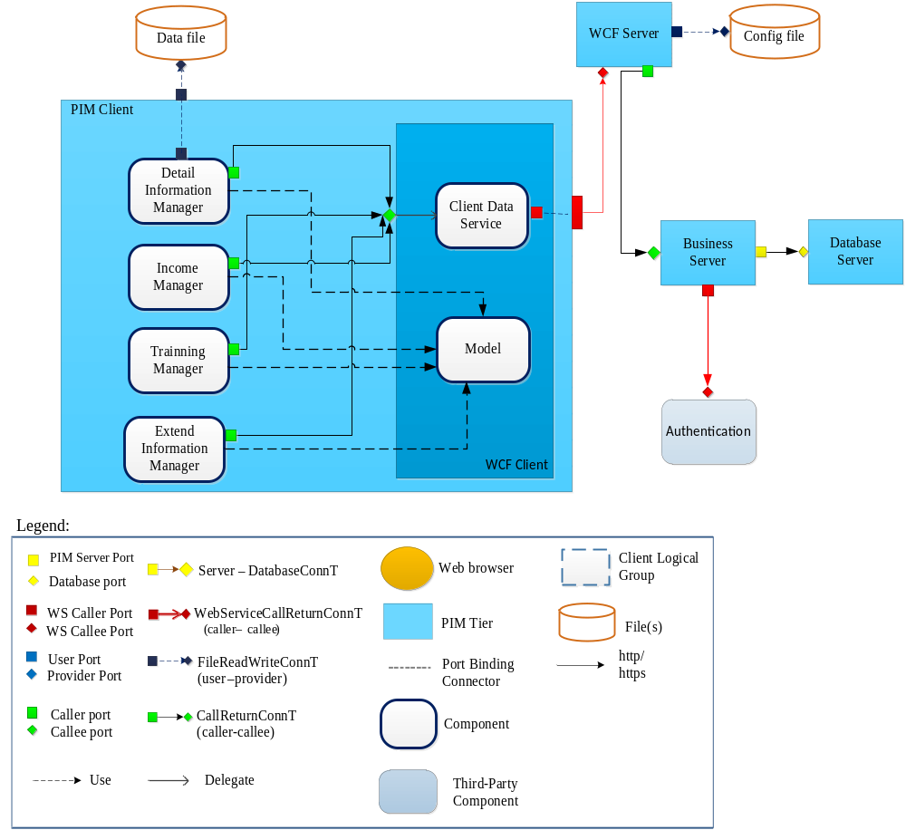

Description of Components
Reference to 6.7: Module views of HRM- PIM system in HRM_Architecture Design Document

Requirements Traceability Matrix
Reference to Requirements Traceability in File List

Data Architecture

Entity-Relation Diagram
Description persistent data structures here including temporary data structures

Temporary data structure(s)
Data structures that are passed among components the software are described

File List Description
Reference to File List

Detail Design
Reference to Detail Design

